[Email Header Image:]
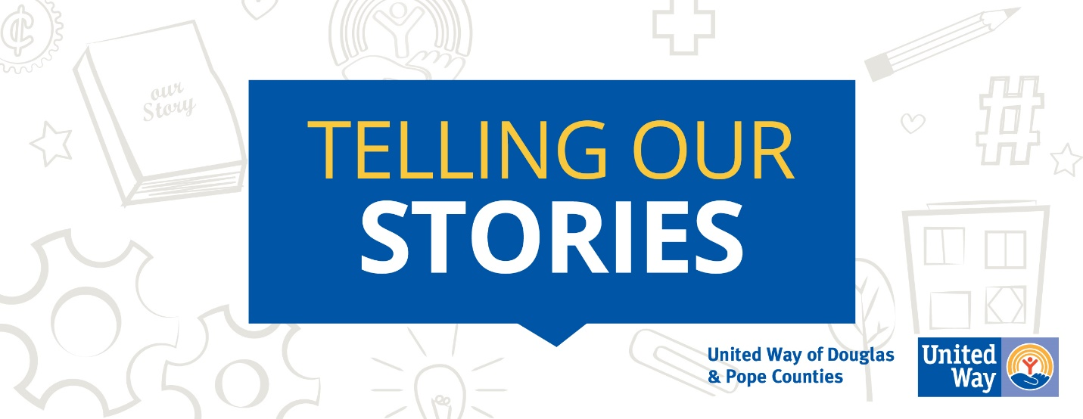

[Email Template:]
Sharing Our Stories.
This year United Way’s campaign theme is focused on telling stories. Stories from United Way and those they have served, stories from our volunteers, donors and grant recipients. Connecting donors and supports with the many ways they have helped create change here in our community. So, to help us get started [here is my story with United Way:] or [Utilize Story 1, 2 or 3 here]

[Story 1:]
A single mom, struggling with her own mental health, was at risk of losing her child to foster care. She signed up to participate in a parent education class funded by United Way along with individual support each week. Through these opportunities she learned new coping strategies for herself and her daughter. She also learned the importance of positive interactions over strict discipline. She was able to form and enjoy a new relationship with her daughter and is now connected with programs that will help her to continue grow and thrive.
- United Way Health Grant Recipient
[Story 2:]
Third grade literacy is an important marker for high school graduation rates. That’s why we focused in to provide a literacy opportunity for our Pre-K - 3rd grade students. The Tree House Program is a fun, free opportunity that removes barriers by traveling to 10 different Douglas County locations. Kids look forward to a chance to meet with friends and hands on learning. Each visit is concluded with a free book so kids can continue their excitement about reading (or being read to) throughout the week.
- United Way Education Program

[Story 3:]
Seeking out a better life for his family, a gentleman was offered and accepted a job in a trade he had no prior experience (or the work tools). Knowing he would not have a paycheck for a couple of weeks (and worried not having those tools could negatively affect his productivity) he contacted us and requested Equipped to Works assistance in purchasing job specific tools.
After completing his due diligence, the program assisted in purchasing job specific tools within days of the request. Today, the gentleman maintains full-time employment. He has expressed his gratitude for having faith in him and for the Equipped to Work funding for the tools he needed to start his new career. He plans to “pay it forward”.
- United Way Financial Stability Program
Please consider a donation through your payroll deduction to create opportunities for everyone’s story to have a happily ever after.
Click HERE to DONATE online or Text: PAYROLL To: 40403
We are here for you! It's in times of need, that we discover the full impact of a community that LIVES UNITED.
Story Flipbook
United Way Goals
United Way Resources

Links:
Donate online: https://uwdp.org/get-involved/give/donate.html
Text Donation: Text: Payroll To: 40403

