United Way Campaign Communication Templates
Pre-Campaign/Campaign Kick Off
Subject: Support our community through United Way!
Body: (Consider using the images provided in this document for e-mail headers from each of our priority areas)
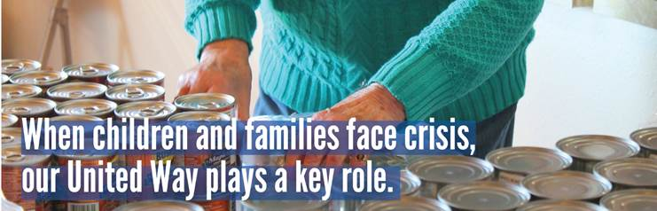
We are gearing up to kick off our own United Way Campaign on (Insert Date Here).
OR Our United Way Campaign kicks off today!
Our campaign theme for this year is “Then, Now, and Into the Future.” For 50 years, United Way has been serving our community. Thanks to YOU, United Way will be here into the future to support the health, education, and financial stability of our community!
With increased costs, people of all ages are unsure of how they will make ends meet. United Way can help!
Here is a glimpse what our local United Way is doing:
- Providing Backpack Attack bags of supplemental food to students.
- Providing school supplies to students through the Stuff the Bus program.
- Offering Food Drops to feed families each month in Douglas & Pope Counties.
- Assisting individuals in finding jobs to support their families through Equipped to Work.
- Providing Grants to nonprofits whose work will be needed both now and into the future.
- 2-1-1 hotline that can be utilized for information on community resources.
CLICK HERE to learn more about the great work United Way is doing in our community.

Campaign Dates: (Insert Dates Here)
Campaign Fun: Throughout the campaign, you will have an opportunity to participate in events that will support our community through United Way.
- Insert Campaign Activity Here
- Insert Campaign Activity Here
- Insert Campaign Activity Here
Giving Options:
- Give Online
- Paper Pledge Form
- Text PAYROLL to 40403
- Sustainable Donor – Check with Payroll to see if you can keep your donation going year over year.
Thank you for LIVING UNITED with (Company Name)!
(Insert CEO or Campaign Committee names)

During/Mid-Campaign
Subject: It’s not too late to make an impact through United Way!
Body: (Consider using the images provided in this document for e-mail headers from each of our priority areas)
Keep those pledges coming…our campaign concludes on (Insert Date Here).
OR Thank you to those who have already submitted your pledge form. If you haven’t already, please complete and return by (Insert Date Here).
If you wondered if your donation could make a difference, IT CAN! Your gift combined with the gifts of others can provide food and housing for children and adults of all ages, safety and mental health support for those experiencing hardship, educational opportunities for children and employment resources for adults. Together we can help families to be financially stable and self-sufficient.

We are asking for your help. Together we can make a difference in addressing our communities’ greatest needs! Please consider a donation to keep our community strong now and into the future!
Thank you for LIVING UNITED with (Company Name)!
(Insert CEO or Campaign Committee names)
Post-Campaign/Celebration
Subject: Thanks for making a difference with United Way!
Body: (Consider using the images provided in this document for e-mail headers from each of our priority areas)
Thanks to an awesome team!
We are excited to reveal the results from our Annual United Way Campaign…but before we dive into the numbers, THANK you for another AMAZING campaign. (Share stories from campaign activities) It was heartwarming to see the level of engagement in the activities and to experience the love our team has for our local community. You guys ROCK!
Campaign Highlights: (Insert memorable moments from your campaign-see ideas below)
- Campaign Presentation – Learning about community needs and United Way impact.
- FUN activities to raise money and build community.
- Celebrations of funds raised.

Campaign Photos: (Insert photos or link here)
Campaign Results: (Insert your company results-see ideas below)
- Total Funds Raised
- % Employee Participation
- Other (Corporate Gift, Company Fundraisers, Volunteer Time, etc.)
And one last THANK YOU to the amazing committee for putting the “FUN” in FUNdraising!
Congratulations on another successful campaign to support our community!
Thank you for LIVING UNITED with (Company Name)!
(Insert CEO or Campaign Committee names)
Campaign Images
Each image aligns with one of our priority areas. Let us know if you would like impact statements for each.
