Email Header Image:

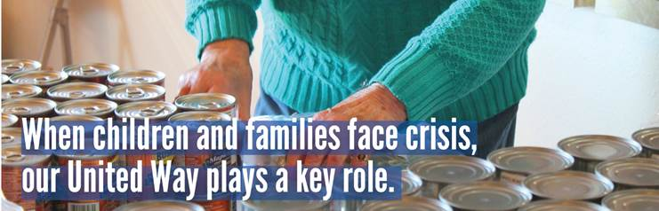

Email Template:
Now more than ever United Way needs your help as COVID-19 spreads.
With changes to income many are now unsure of how they will make ends meet.
The need is very real, which makes many of our grant recipients and United Way programs more critical than ever.

Here is a glimpse what our local United Way is doing:
- Providing Backpack Attack bags of supplemental food to students.
- Providing school supplies to students through the Stuff the Bus program.
- Offering Food Drops to feed families each month in Douglas & Pope Counties.
- Providing Grants to non-profits whose work will be needed both now and in to the future.
- United Way has a 2-1-1 hotline that can be utilized for information on community resources.
United Way is asking for your help. Please consider a donation through your payroll deduction to keep our community strong.
Click HERE to DONATE online or Text: PAYROLL To: 40403
We are here for you! It's in times of need, that we discover the full impact of a community that LIVES UNITED.
Campaign Video
United Way Goals
United Way Resources

Links:
Donate online: https://uwdp.org/get-involved/give/donate.html
Text Donation: Text: Payroll To: 40403

